Appendix

Element, lowest detected limit in dataset and maximum concentration limits from Canadian Drinking Water Standards
Element | Lowest Detected Limit in Dataset [μg/L] | Half Value of Lower Limit [μg/L] | Canadian Drinking Water Standard Maximum [μg/L]
As | 0.00002 | 0.00001 | 0.010
Ca | 0.05 | 0.025
Cd | 0.000005 | 0.0000025 | 0.007
Chloride | 0.5 | 0.25
Iron | 0.001 | 0.0005
Mg | 0.005 | 0.0025
Mn | 0.000008 | 0.000004 | 0.12
P | 0.002 | 0.001
Pb | 0.000005 | 0.0000025 | 0.005
K | 0.05 | 0.025
U | 0.000002 | 0.000001 | 0.02
Na | 0.05 | 0.025
N:Kjel | 0.01 | 0.005
Residue Filterable 1.0u | 10 | 5
Specific conductance | 1 | 0.5
Sulfat:D | 0.3 | 0.15
Alkalinity 4.5 | 0.5 | 0.25
Hardness | .5 | .25

B.C Aquifer Subtype Code
Aquifer Subtype Code | Description
1a | Predominantly unconfined fluvial or glacio-fluvial sand and gravel Aquifers found along major rivers of higher stream order with the potential to be hydraulically influenced by the river.
1b | Predominantly unconfined fluvial or glacio-fluvial sand and gravel Aquifers found along rivers of moderate stream order with the potential to be hydraulically influenced by the river.
1c | Predominantly unconfined fluvial or glacio-fluvial sand and gravel Aquifers found along lower order (< 3-4) streams in confined valleys with relatively undeveloped floodplains, where aquifer thickness and lateral extent are more limited.
2 | Predominantly unconfined deltaic sand and gravel aquifers are commonly found in deltas where a stream or smaller river flows into a standing body of water.
3 | Alluvial or colluvial fan sand and gravel aquifers typically occur at or near the base of mountain slopes, either along the side of valley bottoms, or if formed during the last period of glaciation, raised above the valley bottoms.
4a | Unconfined glacio-fluvial outwash or ice contact sand and gravel aquifers generally formed near or at the end of the last period of glaciation.
4b | Confined Glacio-fluvial sand and gravel aquifers underneath till, in between till layers, or underlying glacio-lacustrine deposits.
4c | Confined sand and gravel aquifer associated with glacio-marine environments near the coast.
5a | Fractured sedimentary rock aquifers primarily found in association with old sedimentary basins.
5b | Karstic limestone aquifers
6a | Crystalline bedrock aquifers associated with flat-lying to gently-dipping volcanic flows.
6b | Fractured crystalline (igneous intrusive or metamorphic, meta-sedimentary, meta-volcanic, volcanic) rock aquifers
UNK | Unknown

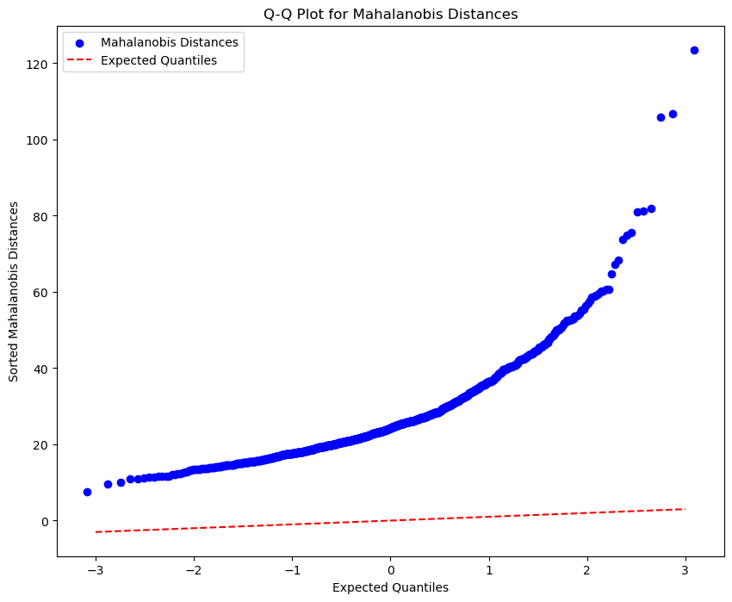
Figure 1

